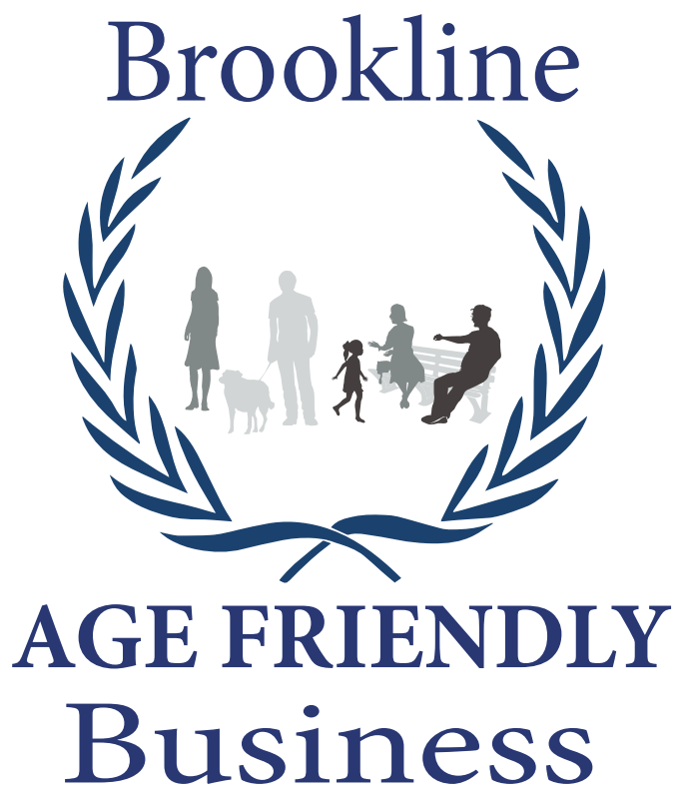
AGE-FRIENDLY BUSINESS APPLICATION
Please complete one application for each business location
Businesses with multiple Brookline locations may request one application for all
Date:
Business Name:
Doing Business As:
Address:
Contact Name/Title:
Phone: |  | Website:
Email Address:

Industry: (check all that apply) | ☐ Arts and Entertainment | ☐ Professional/Financial Services
 | ☐ Automotive | ☐ Real Estate
 | ☐ Barber/Beauty/Spa Services | ☐ Retail Services and Goods
 | ☐ Food, Beverage, Grocery | ☐ Sports and Fitness
 | ☐ Health and Medical | ☐ Telecommunications
 | ☐ Hotel/Travel/Tourism | ☐ Utilities
 | ☐ Other (please describe):

Eligibility. To receive the age-friendly business designation, the business must:
- Be physically located in Brookline
- Have a valid, non-expired business license
- Strive to make its business hospitable to older people

Application. To apply for the age-friendly business designation, the business must:
- Complete the attached checklist
- Provide supporting documentation if applicable (e.g. photos, copies of ads, links to website)
- Submit application to BrooklineCAN:

Mail: | Brookline Age-Friendly Business Campaign  Apply today!  Participating businesses will be listed on the BrooklineCAN website  BrooklineCAN  93 Winchester Street  Brookline, MA 02446
BROOKLINE AGE FRIENDLY BUSINESS CHECK LIST
 | YES | NO | Does not apply
On your website, do you have a customer assistance phone number that is easy to find?
On your website, do you have contact information that is easy to find?
On your digital materials, do you have a large font or an easy text-resize option on digital materials?
On print materials, do you use LARGE fonts?
If you operate a restaurant, do you limit noise levels and background music to moderate or low levels at lunch and in the early evening?
Do you place products within reach on shelves?
Do you offer help to customers in reaching items?
Do you have a well-lit place where customers can sit and rest?
Do you train staff to assist customers with access and functional needs (e.g. reach shelved items, speak clearly, read labels/menus)?
Do you have drop-off or delivery service?
Do you offer shopping by phone or on-line shopping?
Please list any discount programs you have for seniors.
Describe other services that you offer that make your business attractive to seniors
Is there something you are particularly proud of in your offerings to seniors?
Our business would like assistance with:
____ Designing printed documents that are easy for older people to read
____ Designing my website so that it is easy for older people to use
____ Training staff to work effectively with older people

Signature |  | Business |  | Date

